Project Report Format

# INTRODUCTION

* 1. Project Overview:

The **Sustainable Smart City Assistant Using IBM Granite LLM** is an AI-powered solution designed to support environmentally conscious urban living by offering intelligent insights, guidance, and decision-making tools. By leveraging IBM's Granite large language model, the assistant can understand, analyze, and respond to sustainability-related queries in real time. The system integrates several components including eco-tips, KPI forecasting, anomaly detection, feedback collection, and policy summarization—making it a robust assistant for both citizens and city planners aiming for greener urban management.

* 1. Purpose:

The primary purpose of this project is to:

* Provide city residents with **personalized sustainability guidance**.
* Assist city officials in **monitoring key sustainability metrics** and policies.
* Enable **data-driven decisions** through intelligent summarization of environmental policies and reports.
* Promote **citizen participation** by collecting feedback and encouraging eco-conscious behavior.
* Demonstrate the real-world application of IBM Granite LLM in the **smart city ecosystem**.

# IDEATION PHASE

* 1. Problem Statement:

As cities grow increasingly complex and resource-intensive, urban residents and administrators face challenges in making sustainable decisions that balance development with environmental responsibility. Citizens often lack access to reliable, actionable information about their environmental impact, while city officials struggle to analyze and communicate sustainability data effectively. There is a need for an intelligent assistant that can bridge this gap—enabling proactive eco-friendly behaviors and informed governance through real-time insights and engagement.

* 1. Empathy Map Canvas:

**User Persona**: City resident / Smart city planner

* **Thinks**:
  + "Am I doing enough to help the environment?"
  + "I need simple, trusted information to make better choices."
* **Feels**:
  + Concerned about rising pollution and climate change.
  + Overwhelmed or confused by technical sustainability data.
  + Frustrated by lack of clear communication from city authorities.
* **Says**:
  + "I wish the city provided clear and practical eco-tips."
  + "These sustainability reports are too complex to understand."
  + "I want to contribute, but I don’t know how."
* **Does**:
  + Searches online for eco-friendly practices.
  + Skips or ignores long policy documents and emails.
  + Tries to recycle or reduce energy use when reminded.
  + Shares concerns or ideas occasionally on social media or forums.
* **Pain Points**:
  + Lack of access to understandable and actionable sustainability information.
  + Limited ways to provide feedback to city services.
  + Inability to see the direct impact of personal or community actions.
* **Gains**:
  + Personalized recommendations for greener living.
  + A platform to voice feedback and suggestions.
  + Simple summaries of city policies and sustainability efforts.
  + Motivation through visible progress and engagement.
  1. Brainstorming:

To address the challenges identified, the following ideas were generated during brainstorming:

* An interactive **chat assistant** that answers sustainability questions using IBM Granite LLM.
* A module that provides **daily eco-tips** based on personal habits and location.
* **KPI forecasting** to visualize energy, water, or waste metrics and track progress.
* **Policy summarization** using LLM to translate dense government reports into citizen-friendly summaries.
* **Feedback collection** to allow residents to suggest green ideas or report issues.
* Use of **smart dashboards** to visualize city-wide sustainability performance in real-time.
* Embed **anomaly detection** to alert for unusual spikes in energy or water usage.

# REQUIREMENT ANALYSIS

* 1. Customer Journey map:

**Stage 1: Discover Assistant**

* **Goal**: Learn about the assistant's capabilities.
* **Action**: Opens smart city app or website.
* **Experience**: Sees prompt to try AI assistant for sustainability help.
* **Pain Point**: Unclear how to begin.
* **Opportunity**: Provide onboarding tips and short demo.

**Stage 2: Ask Questions**

* **Goal**: Get eco-friendly advice and city data.
* **Action**: Types or speaks a query like “How to reduce electricity usage?”
* **Experience**: Receives AI-generated tips and visual insights.
* **Pain Point**: May get overwhelmed by data.
* **Opportunity**: Offer simplified summaries and quick actions.

**Stage 3: Take Action**

* **Goal**: Act on assistant's suggestions.
* **Action**: Applies tips, downloads report, or books a related service.
* **Experience**: Feels empowered and involved.
* **Pain Point**: Unsure of real impact.
* **Opportunity**: Provide feedback loop and eco-score tracking.

**Stage 4: Share Feedback**

* **Goal**: Report issues or suggest improvements.
* **Action**: Submits form or speaks feedback.
* **Experience**: Gets confirmation but no clear follow-up.
* **Pain Point**: Feels feedback is ignored.
* **Opportunity**: Show progress tracker or public dashboard.

**Stage 5: Re-engage**

* **Goal**: Stay updated with sustainability progress.
* **Action**: Returns for updated forecasts, new tips, or reports.
* **Experience**: Personalized experience improves over time.
* **Pain Point**: May lose interest.
  1. Solution Requirement:

**Functional Requirements**

* Chat interface to interact with IBM Granite LLM.
* Eco-tips generation module.
* KPI forecasting and visualization tools.
* Policy summarization and report explanation.
* Feedback collection system.
* User profile and interaction history.

**Non-Functional Requirements**

* Responsive design for mobile and desktop.
* Fast response time (< 2 seconds).
* Secure API and data handling.
* Scalable backend infrastructure.
* User data privacy compliance (e.g., GDPR).
  1. Data Flow Diagram:

**Level 0 – Context Level**

* **User** → interacts with → **Smart City Assistant UI**
* **Smart City Assistant** ↔ fetches/sends data from/to:
  + **IBM Granite LLM** (for language understanding)
  + **KPI Database** (for city metrics)
  + **Policy Document Repository** (for summarization)
  + **Feedback Storage** (for feedback and reports)
  1. Technology Stack:

**Backend**:

* Python (FastAPI or Flask)
* IBM Granite LLM SDK
* Pandas/NumPy (data processing)
* streamlit

# PROJECT DESIGN

* 1. Problem Solution Fit:

Urban citizens and city administrators face significant barriers in understanding and acting on sustainability data. Traditional systems offer fragmented information, lack personalization, and fail to engage users effectively. The **Sustainable Smart City Assistant using IBM Granite LLM** directly addresses these gaps by providing:

* **Natural language interactions** for intuitive eco-related queries.
* **Summarized policy insights**, reducing information overload.
* **Real-time visual forecasts** of sustainability KPIs.
* **Personalized recommendations** that encourage green behaviors.
* **Feedback mechanisms** for inclusive urban planning.

This solution fits the problem by simplifying complex data, promoting eco-conscious actions, and involving users in a meaningful way.

* 1. Proposed Solution:

The proposed solution is a **Smart City AI Assistant** powered by IBM’s Granite LLM that integrates multiple sustainability tools into a single platform. Key features include:

* **AI Chatbot Interface**: Allows users to ask questions in natural language and receive eco-tips or city insights.
* **Policy Summarization**: Uses LLM to convert lengthy environmental documents into digestible summaries.
* **KPI Forecasting & Visualization**: Displays trends in energy, water usage, and pollution with predictive analytics.
* **Feedback Module**: Enables users to suggest improvements or report concerns.
* **User Dashboard**: Tracks eco-behavior, engagement history, and provides personalized suggestions.

# PROJECT PLANNING & SCHEDULING

* 1. Project Planning:

The development of the **Sustainable Smart City Assistant using IBM Granite LLM** is planned in the following key phases:

**1. Problem Understanding & Research**

* Define the main sustainability challenges faced by urban citizens.
* Analyze how IBM Granite LLM can solve these challenges.
* Collect relevant datasets and documents (KPI, policies, eco-tips).

**2. Design Phase**

* Design the user flow and customer journey map.
* Create empathy map and brainstorm use cases.
* Plan the architecture using a simple Streamlit-based interface.

**3. Development Phase**

* Use **Streamlit** to build the full-stack app (UI + backend logic).
* Integrate IBM Granite LLM API for natural language understanding and summarization.
* Develop modules for:
  + Chat-based assistance
  + KPI forecasting and graph display
  + Feedback collection
  + Policy summarization
  + Eco-tip recommendations

**4. Testing & Refinement**

* Test all functionalities in the Streamlit app.
* Validate responses from the assistant.
* Check data accuracy and ensure smooth user experience.

**5. Finalization & Deployment**

* Add final UI elements and improve layout in Streamlit.
* Prepare documentation, demo video, and final project report.

# FUNCTIONAL AND PERFORMANCE TESTING

* 1. Performance Testing:

Performance testing ensures that the Sustainable Smart City Assistant using IBM Granite LLM operates efficiently under expected usage conditions. Since the application is developed using Streamlit and depends on responses from IBM Granite LLM, key performance aspects are measured around speed, responsiveness, and load handling.

**Objectives of Performance Testing:**

* Ensure the application responds quickly to user inputs.
* Verify that the Granite LLM API integration handles requests efficiently.

# RESULTS

* 1. Output Screenshots

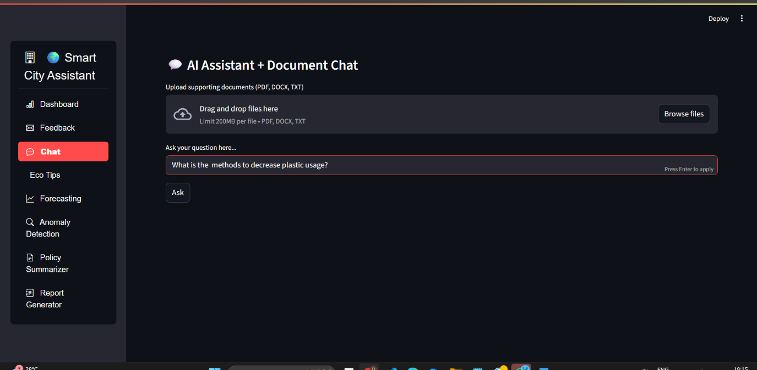

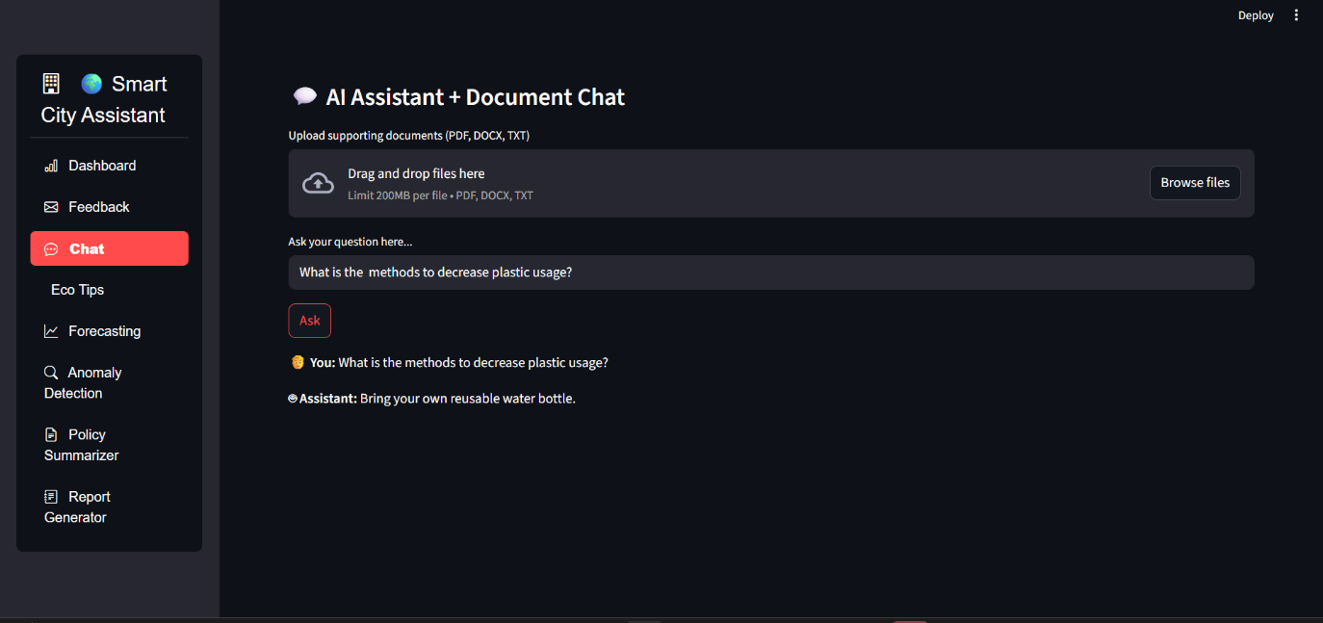

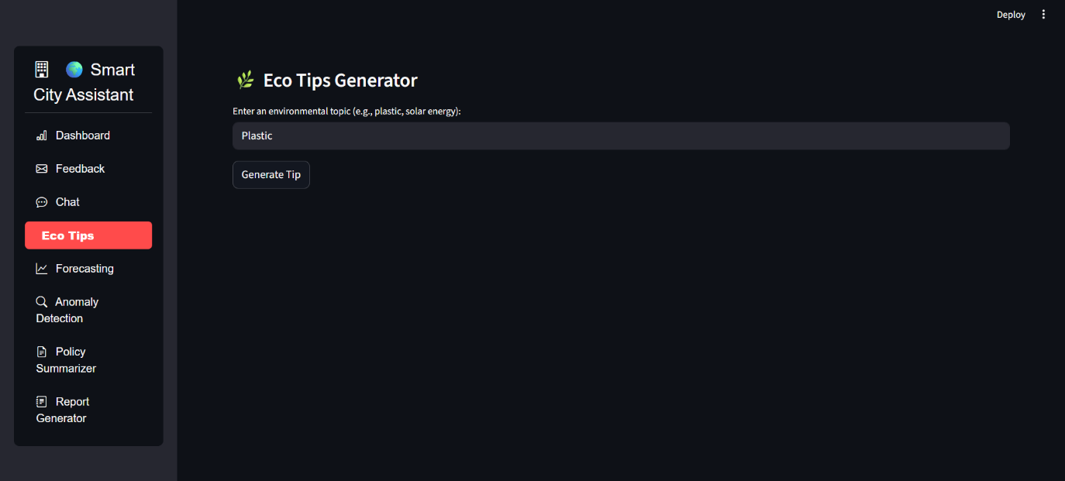

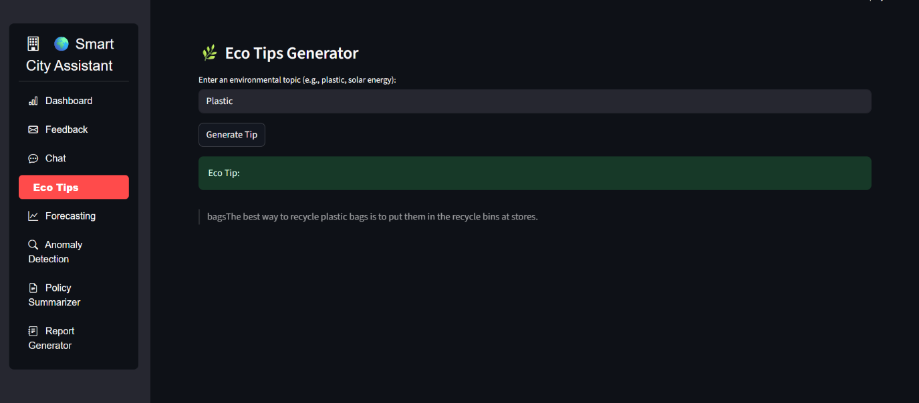

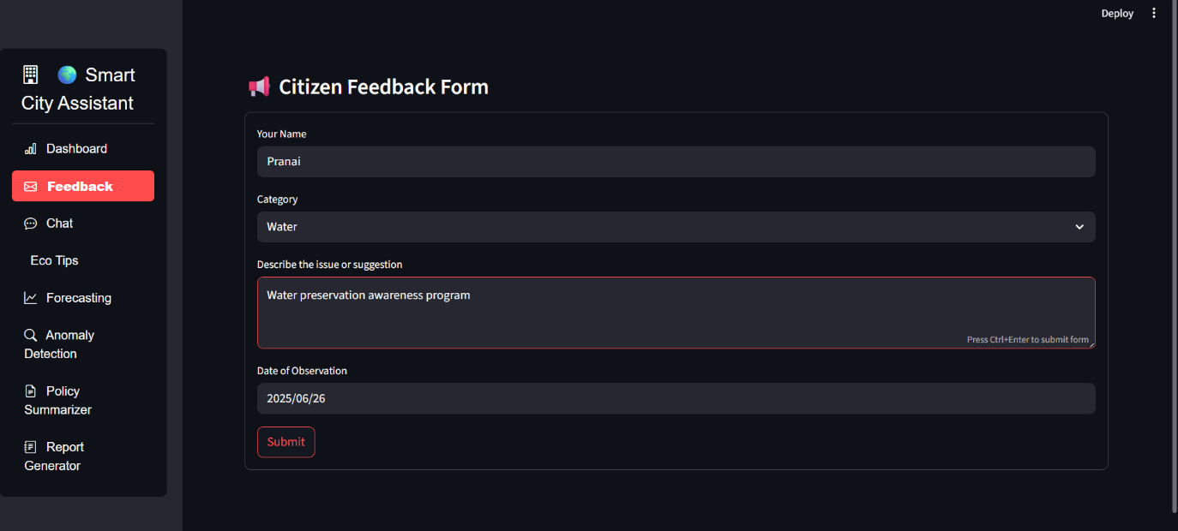

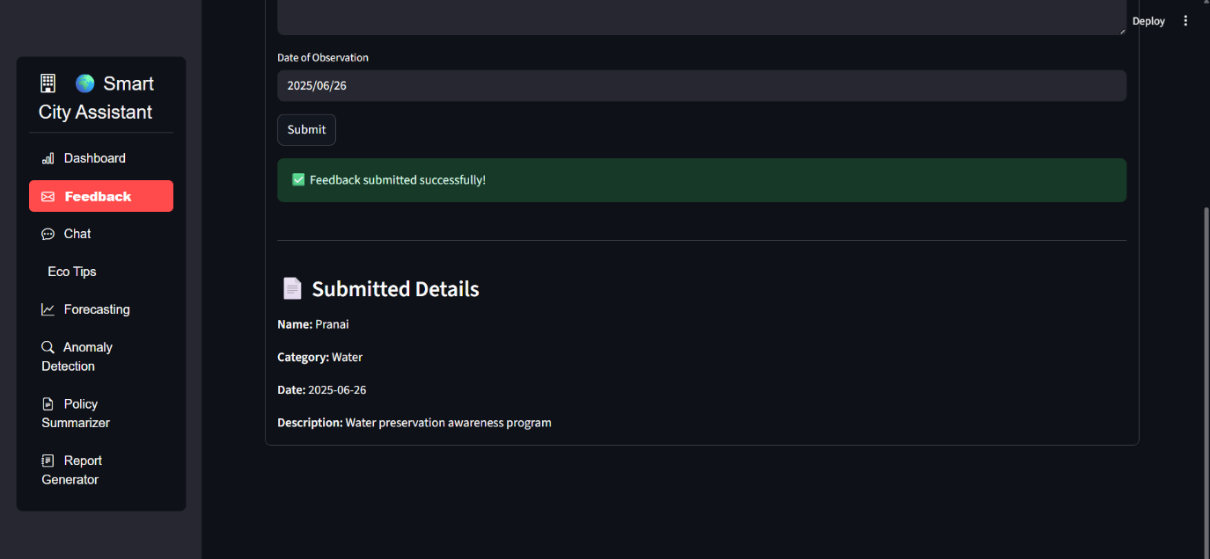

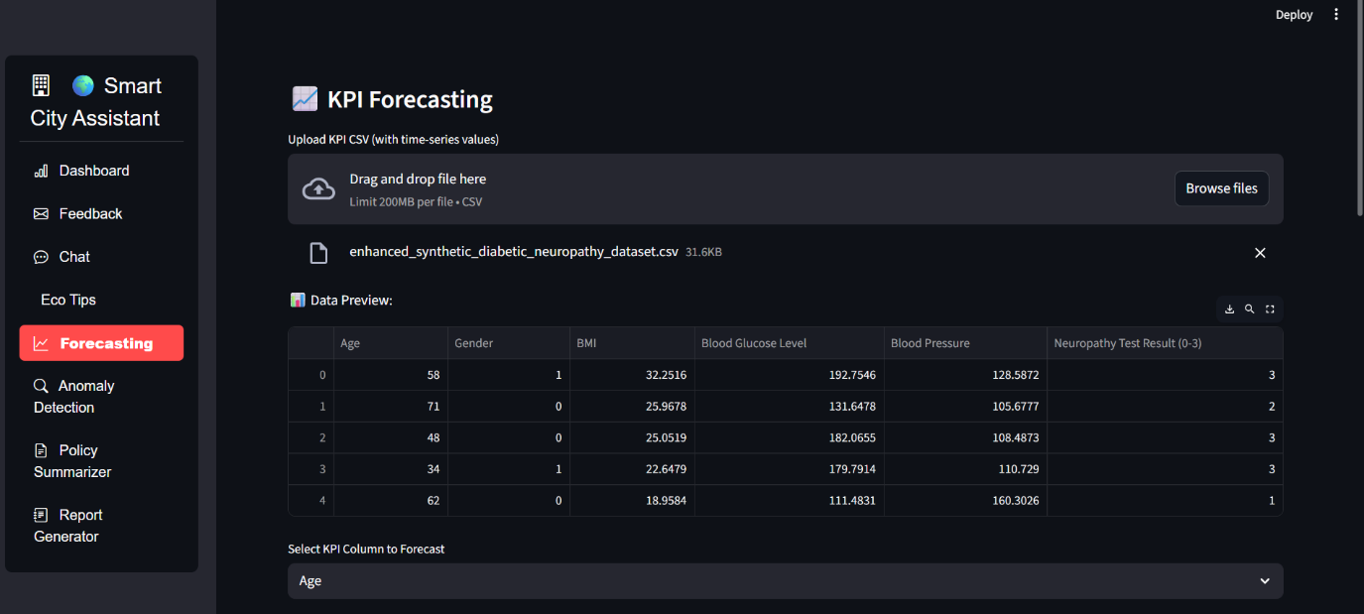

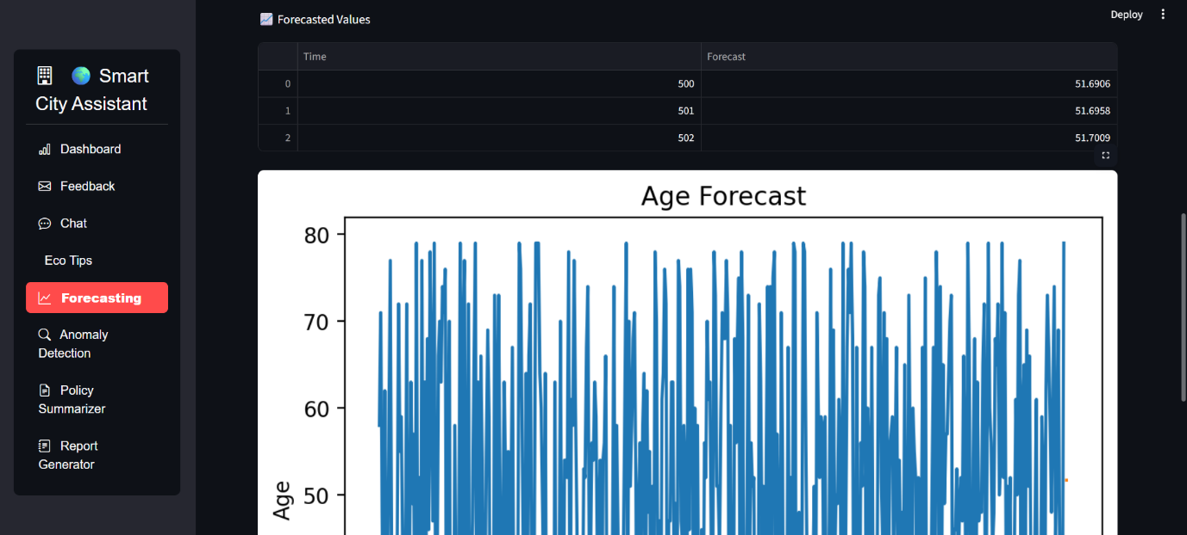

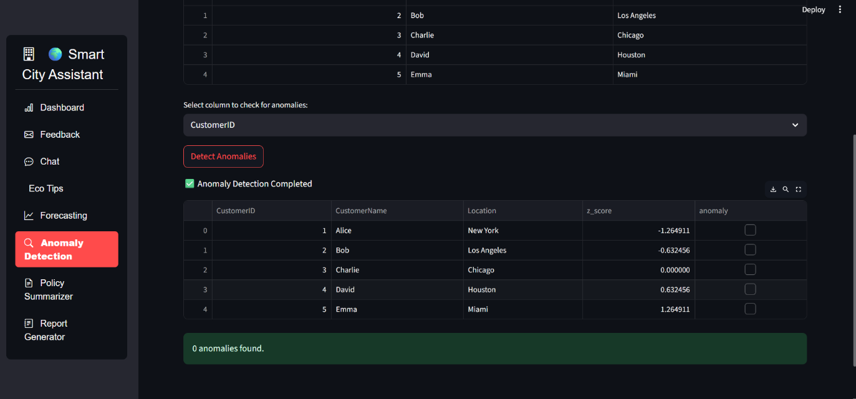

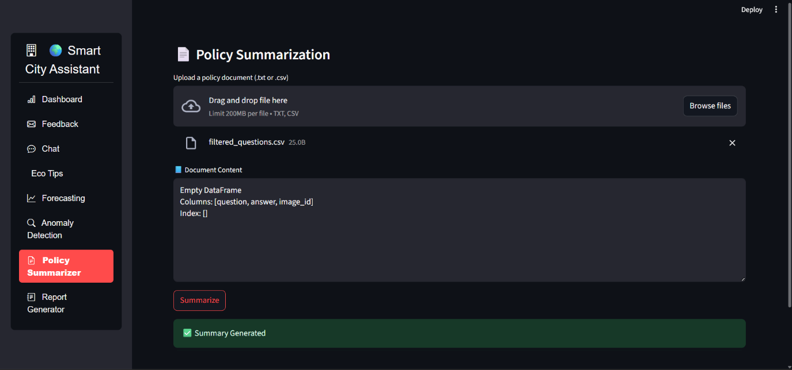

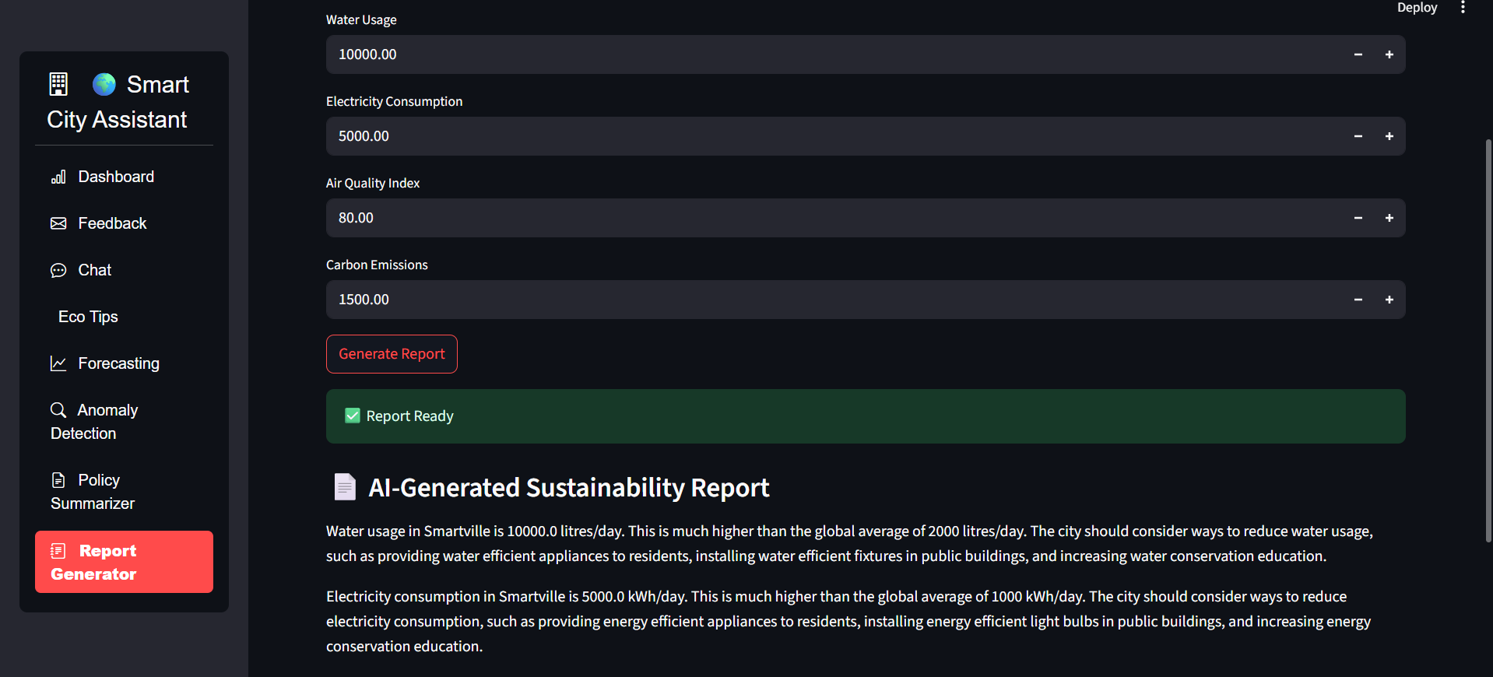

1. **ADVANTAGES & DISADVANTAGES:**

**Advantages of the Sustainable Smart City Assistant Using IBM Granite LLM:**

1. **AI-Powered Automation**  
   The use of IBM Granite LLM enables automatic summarization of policies, natural language chat interaction, and sustainability report generation, saving time and effort.
2. **Enhanced Civic Engagement**  
   Citizens can actively participate by submitting feedback, asking eco-related questions, and accessing simplified city policies, improving transparency and interaction.
3. **Data-Driven Decision Making**  
   With KPI forecasting and anomaly detection, city planners can make informed decisions regarding infrastructure and resource allocation.
4. **Scalable and Modular Architecture**  
   The modular backend (FastAPI) and frontend (Streamlit) allow easy updates, feature additions, and scalability for future enhancements.
5. **User-Friendly Interface**  
   Streamlit ensures a smooth, clean, and responsive interface accessible to both technical and non-technical users.
6. **Advanced Document Search**  
   Pinecone’s semantic search capabilities allow intelligent and context-aware document retrieval for planners and citizens.
7. **Sustainability Focus**  
   The app actively promotes sustainable practices by providing actionable eco-tips and raising awareness of carbon and resource usage.
8. **Supports Multiple Data Formats**  
   Users can upload and interact with data in CSV, text, or PDF format, making it flexible for real-world government data inputs.

**Disadvantages of the Sustainable Smart City Assistant:**

1. **Dependence on External APIs**  
   The project heavily relies on IBM Watsonx APIs. If API limits are reached or services are unavailable, key features may become non-functional.
2. **Infrastructure Cost**  
   Hosting and using IBM Watsonx, Pinecone, and cloud services can incur high operational costs, especially at scale.
3. **Data Privacy Concerns**  
   Uploading sensitive city data or documents to external LLM services may raise data security and privacy issues.
4. **Limited Offline Support**  
   As a web-based solution, the assistant requires an internet connection, limiting usability in low-connectivity areas.
5. **Complex Initial Setup**  
   Integrating Pinecone, Watsonx, and setting up FastAPI and Streamlit environments may be challenging for beginners.
6. **Model Limitations**  
   While IBM Granite is powerful, it may still produce generic or incorrect responses if prompts are ambiguous or datasets are inconsistent.
7. **CONCLUSION:**
8. The **Sustainable Smart City Assistant** successfully demonstrates how artificial intelligence, natural language processing, and data analytics can be integrated to support urban sustainability, governance, and citizen engagement. By leveraging IBM WatsonX’s Granite LLM, the assistant offers intelligent policy summarization, real-time chat support, KPI forecasting, eco-advice generation, and anomaly detection — all through an accessible, user-friendly interface.
9. The project not only simplifies complex governmental data but also empowers citizens to participate actively in their city’s development. City administrators benefit from data-driven insights, helping them make informed decisions about resource management and infrastructure planning.
10. Through the use of modern technologies like Streamlit, FastAPI, Pinecone, and WatsonX, this assistant lays the foundation for smarter, greener cities. The modular architecture ensures scalability and adaptability to future use cases, making it a valuable tool for municipalities aiming to align with digital governance and sustainability goals.
11. In conclusion, the project bridges the gap between urban complexity and citizen accessibility, paving the way toward transparent, efficient, and eco-conscious smart cities.
12. **FUTURE SCOPE:**

The Sustainable Smart City Assistant has been developed as a modular and scalable system. As such, it holds significant potential for future enhancements and broader applications:

1. Multi-language Support  
   To increase accessibility and inclusivity, the assistant can be extended to support multiple local and international languages using translation models.
2. Mobile Application Integration  
   A companion mobile app can be developed to provide real-time access to chat, feedback, and policy summaries for citizens on the go.
3. Real-time IoT Data Integration  
   Integration with IoT sensors across city zones (e.g., for pollution, traffic, energy use) can allow real-time anomaly alerts and environmental monitoring.
4. Advanced Visualization Tools  
   Incorporating dashboards with interactive charts and heatmaps for KPIs, anomalies, and forecast trends will enhance administrator decision-making.
5. Voice-based Assistant  
   Using speech-to-text and text-to-speech APIs, the assistant can support voice queries for accessibility among elderly or less literate populations.
6. Predictive Resource Management  
   Machine learning models can be trained with historical KPI data to suggest optimal strategies for resource allocation and urban planning.
7. Policy Impact Simulation  
   Integrating simulation tools to visualize the projected impact of proposed policies before implementation would aid city planners.
8. Citizen Reward System  
   A gamified approach can be added where citizens earn points or badges for eco-friendly behavior or helpful feedback submissions.
9. Blockchain for Transparent Feedback Logging  
   Implementing blockchain to securely record citizen feedback and government responses can boost transparency and trust.
10. Deployment Across Cities  
    The assistant can be customized and deployed in other smart cities, making it a reusable product platform with configurable modules.
11. **APPENDIX**

**GITHUB:** [**Pranai222/Smartintern_Project_sdlc**](https://github.com/Pranai222/Smartintern_Project_sdlc/tree/main)